* Observe 2 individuals/groups per team member. For each individual/group observed include the following:
* Basic demographic information about the group
* The most interesting observation and interpretation from your interaction with that individual/group (1-2 sentences)
* A photograph from your interaction with that individual/group (optional)

Every person is responsible for their two interview groups.

**Group 1**

Demographic Information:

* 4 freshmen students from MIT (2 girls, 2 boys)
* Visiting Harvard campus because MIT was still on break
* Age 18-20
* First time on Harvard campus

Most interesting observation + interpretation:

They told me that to show others that they visited Harvard, a photo with the John Harvard statue was a must. John Harvard statue was by far the most desired photo spot, serving as the most iconic point about Harvard campus. Since photo opportunities were important to the tourists, they would like to know where are some great and recommended photo spots on campus.

**Group 2**

Demographic Information:

* 3 male college students from South Korea
* East Coast tour, spent 7 days in NY, stopped by Boston to visit Harvard, MIT, BU, BC, Tufts
* Studied acupuncture, herbal medicine

Most interesting observation + interpretation:

When they visited the Widener library, they were simply amazed by the incredible size and infrastructure. After taking photos outside, they were really curious what the library looked like upstairs, beyond the security entrance. For tourists, many must be curious (like this group) of what the inside looked like so they can get a more complete experience of Harvard.

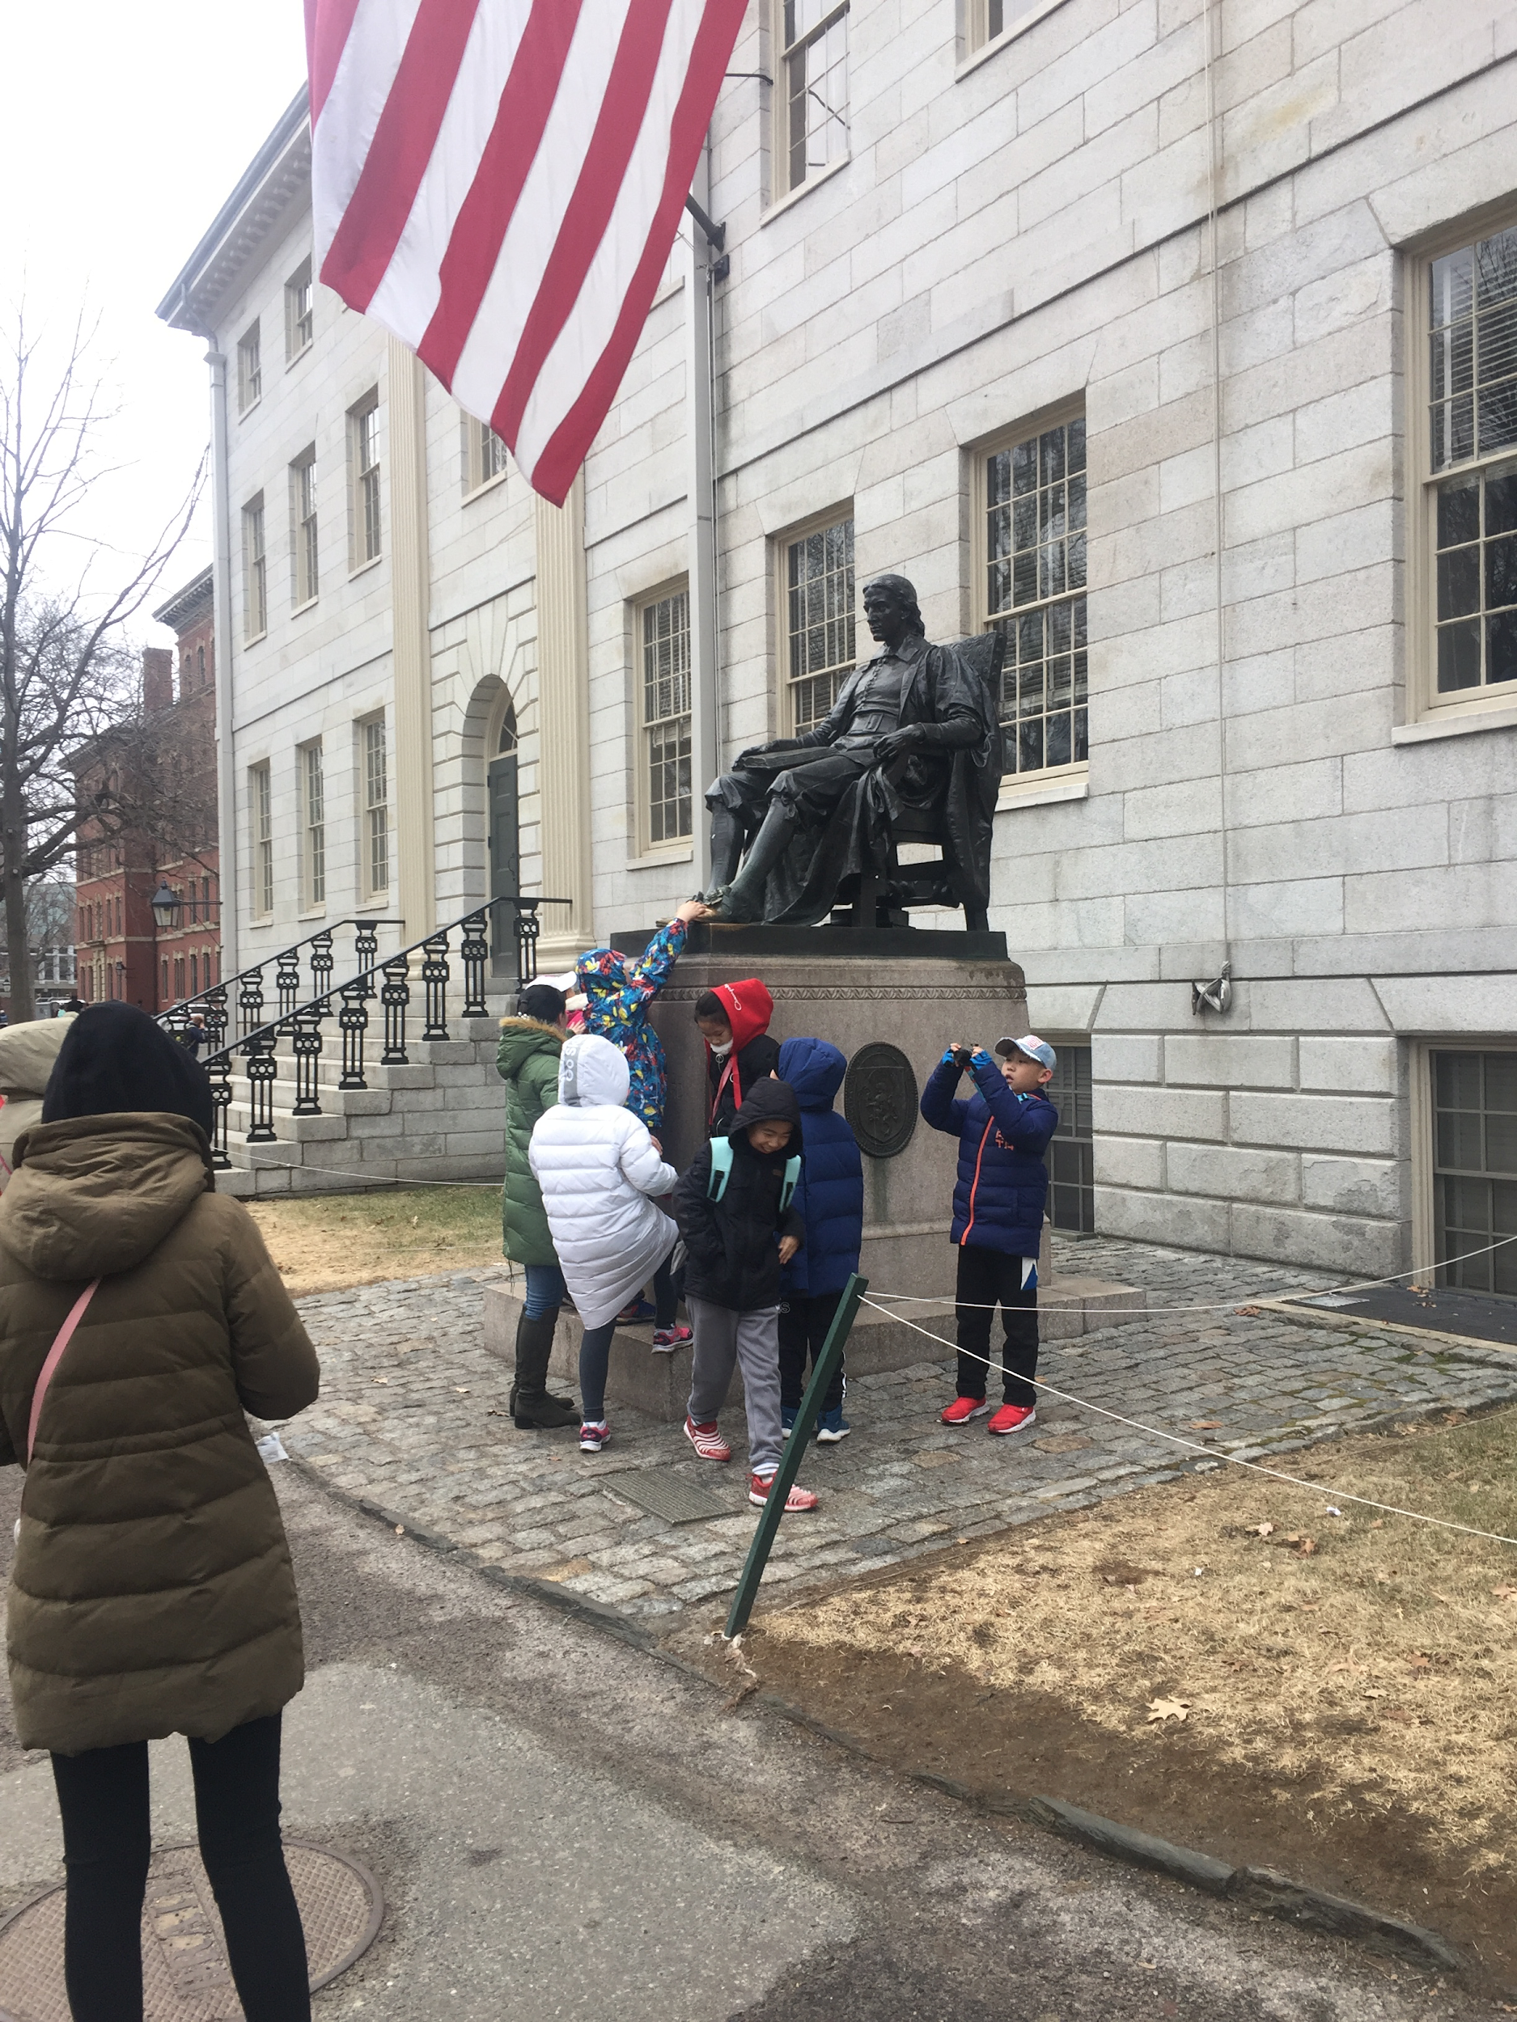

**Group 3**

Demographic Information:

* 10 elementary school students in an after school program from Tianjin, China
* 10 parents of the kids, with varying levels of English
* 12 day schedule in Boston to visit MIT, Harvard, Tufts

Most interesting observation + interpretation:

They had a tour guide who were explaining facts about Harvard in Chinese. The trip was organized by the after school program, which taught English. The purpose of the trip was to inspire kids to learn English. They were interested in Harvard buildings and noticed how they years they were built were marked on them. Because they noticed the years on the buildings, they wished they knew more about how the campus evolved.

**Group 4**

Demographic Information:

* 6 11th grade students from Beijing, China
* 6 parents
* 14 day trip during winter break

Most interesting observation + interpretation:

They had a tour guide who organized the trip with a company who helps kids apply to colleges in America. One student wanted a map but their parent told her to just look it up on google instead so it could be translated online. They used their phones to look up information and communicate.

**Group 5**

Demographic information:

* Colleagues from a fine dining company in Maine
* 8 members in the group
* Ages ranging from 30-50
* A lot of international workers i.e. Zimbabwe, Philippines etc.
* English-speaking

Most interesting observation + interpretation:

This group spent a lot of time milling about and trying to decide what to do next. We interpreted this as a result of the fact that they did not have a tour guide that could make executive decisions and thus needed to spend unnecessary time forming consensus for any new direction that they wanted to take.

**Group 6**

Demographic information:

* Two Chinese moms and two children with a college tour guide/acquaintance studying at Harvard
* Moms were middle-aged and the children were aged 12
* The parents could speak broken English, the kids very little and the college student was fluent

Most interesting observation + interpretation:

The children were very bored and cold and distracted the moms by not cooperating. We interpreted this as a result of Harvard’s campus and tourist offerings not being child-friendly or stimulating enough.